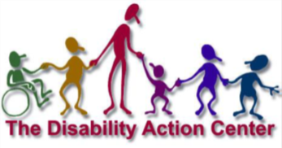
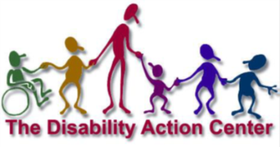
Member Name: _________________________________________ date: _____________________
Parent/Guardian Name____________________________________________________________
address: ___________________ city: __________________ state: _________zip: ____________
phone: ________________________________ email: ____________________________________

Membership Application
Disability Action Center

Community/Social Member | Active Member | All-Inclusive Member
- 1 weekly activity  (1 day or activity)  - Receive mailings, calendar of events, and newsletter  - Covers household attendance  - Free access to fitness room  - Discounted Camp-Can Do Week  - Discounted DAC Bowling**  - Discounted Banquet Hall Rental | - 2-5 weekly activities  (1-2 days)  - Receive mailings, calendar of events, and newsletter  - Covers household attendance  - Free Access to Fitness Room  - Discounted Camp-Can Do Week ($10/day vs. $20/day)  - Discounted DAC Bowling  - Discounted Banquet Hall Rental | - 6+ weekly activities  (3-4+ days)  - Receive mailings, calendar of events, and newsletter  - Covers household attendance  - Free Access to Fitness Room  - Discounted Camp-Can Do Week ($10/day vs. $20/day)  - Discounted DAC Bowling  - Discounted Banquet Hall Rental
I want to be a Community/Social Member for $50 a year | I want to be an Active Member for $100 a year | I want to be an All-Inclusive Member for $150 a year

I would like to make an additional contribution to my membership fee $_______________________
I would like to make an addition contribution $ ____________ in memory of ___________________
I would like to make an additional contribution to the #Higherground Building Fund $___________
I understand that the membership fees do not eliminate the additional payments charged a Friday Night Out, Camp Can-Do, and DAC Bowling but the discount applies if applicable as listed above.
I understand that Experience It Co-Op and Full STEM Ahead fees may apply.

For more information: (304) 366-3213
www.disabilityactioncenter.com
jsole@disabilityactioncenter.com
Please make checks payable to and send them to:
The Disability Action Center
448 Leonard Ave. Fairmont, WV 26554
#HigherGround #HigherPurpose

